LAB EXPERIMENTS

NAME: G.PALLAVI
REG NO: 192311208
COURSE CODE: ITA0512
COURSE NAME: COMPUTER VISION

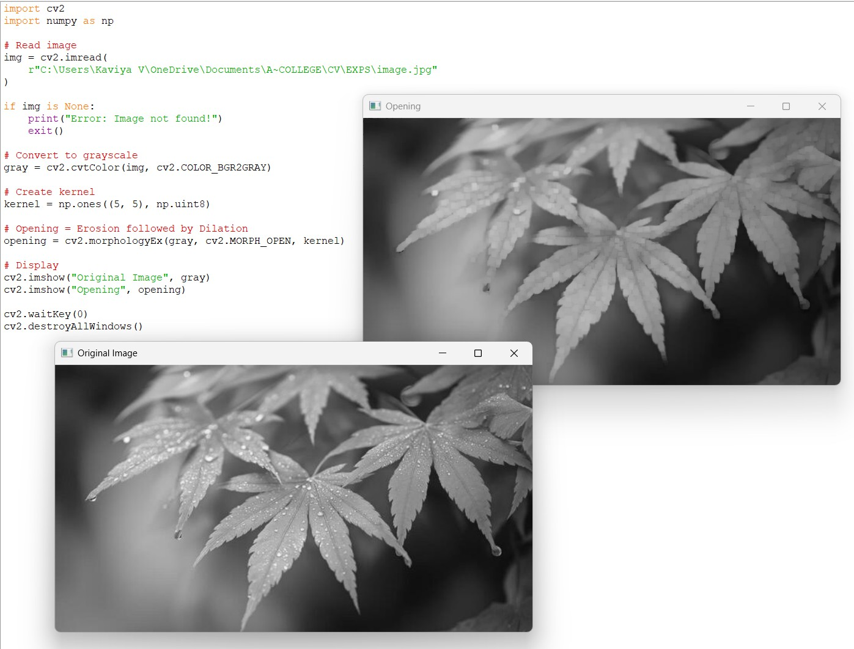
- Implement the Opening technique as a Morphological operation to dilate the foreground regions based on Open CV.
- Implement the Closing technique as a Morphological operation to dilate the foreground regions based on Open CV.
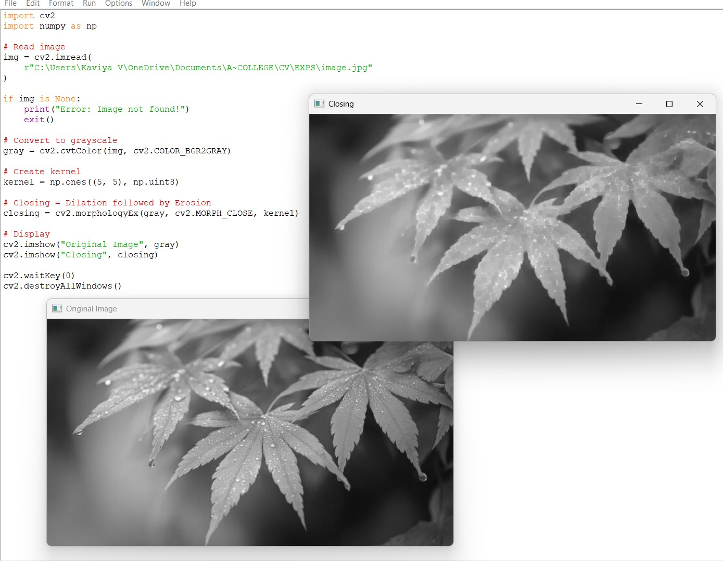

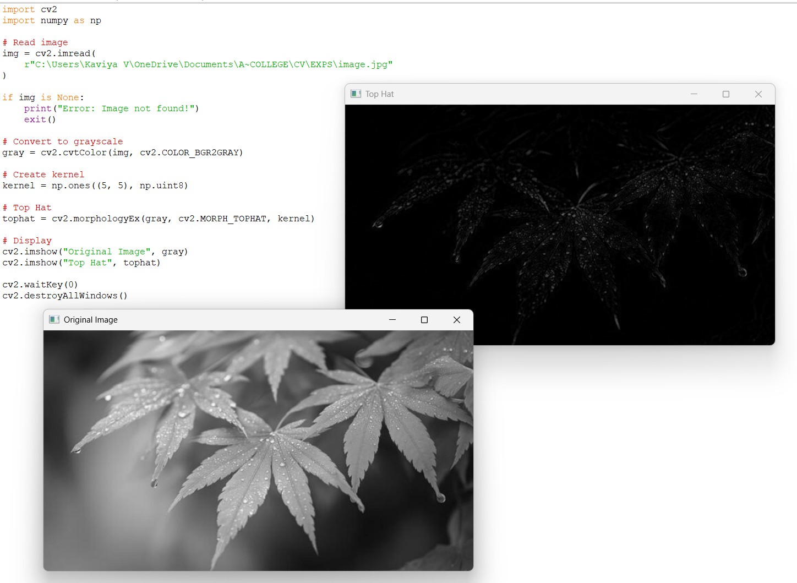
- Implement the Top hat technique as a Morphological operation to dilate the foreground regions based on Open CV.
- Implement the Black hat technique as a Morphological operation to dilate the foreground regions based on Open CV.
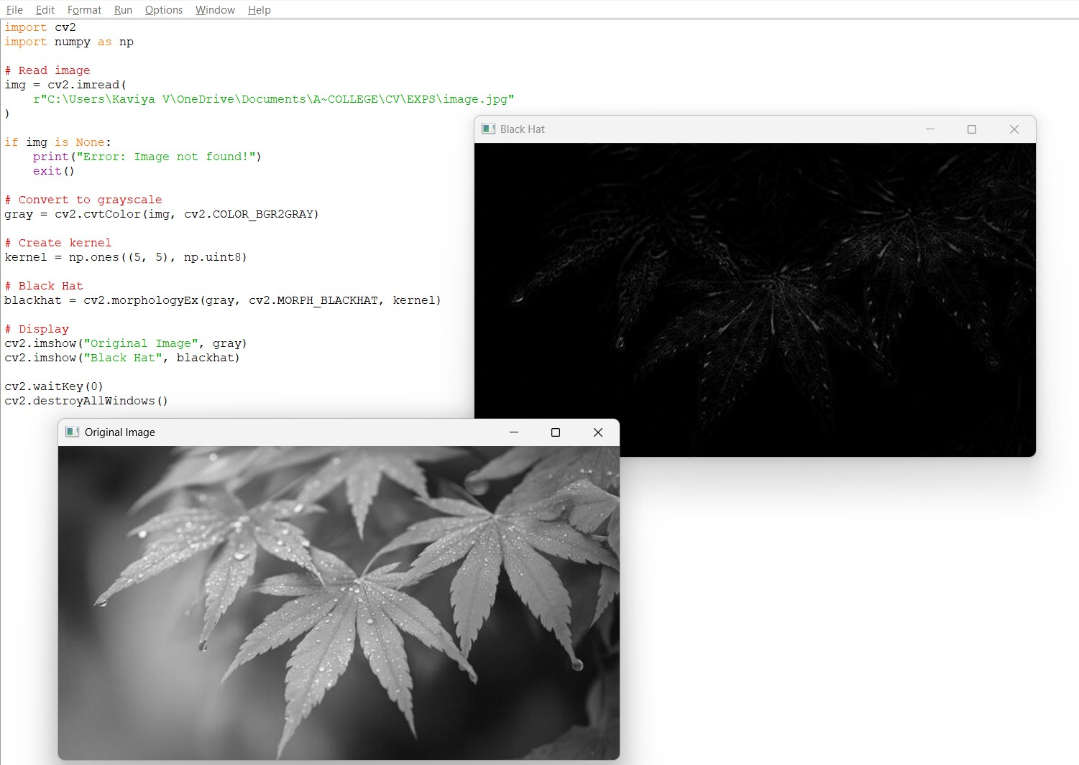

- Recognize watch from the given image by general Object recognition using Open CV.

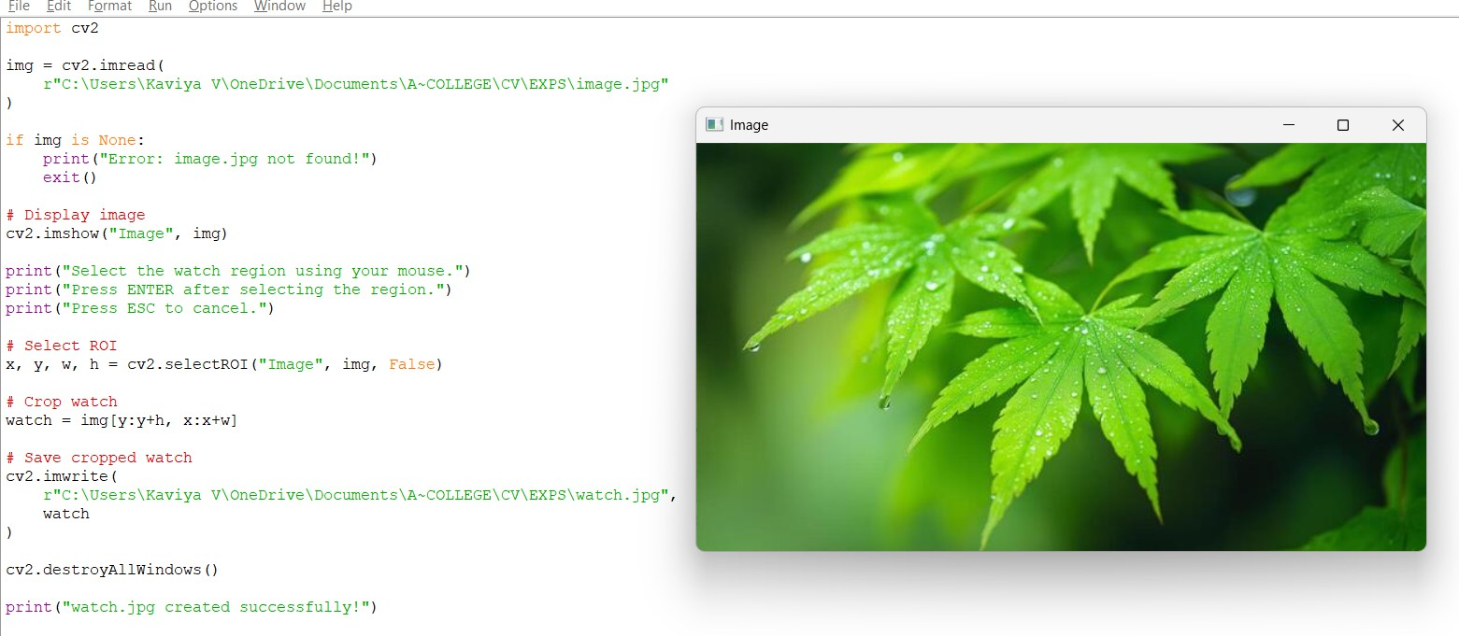
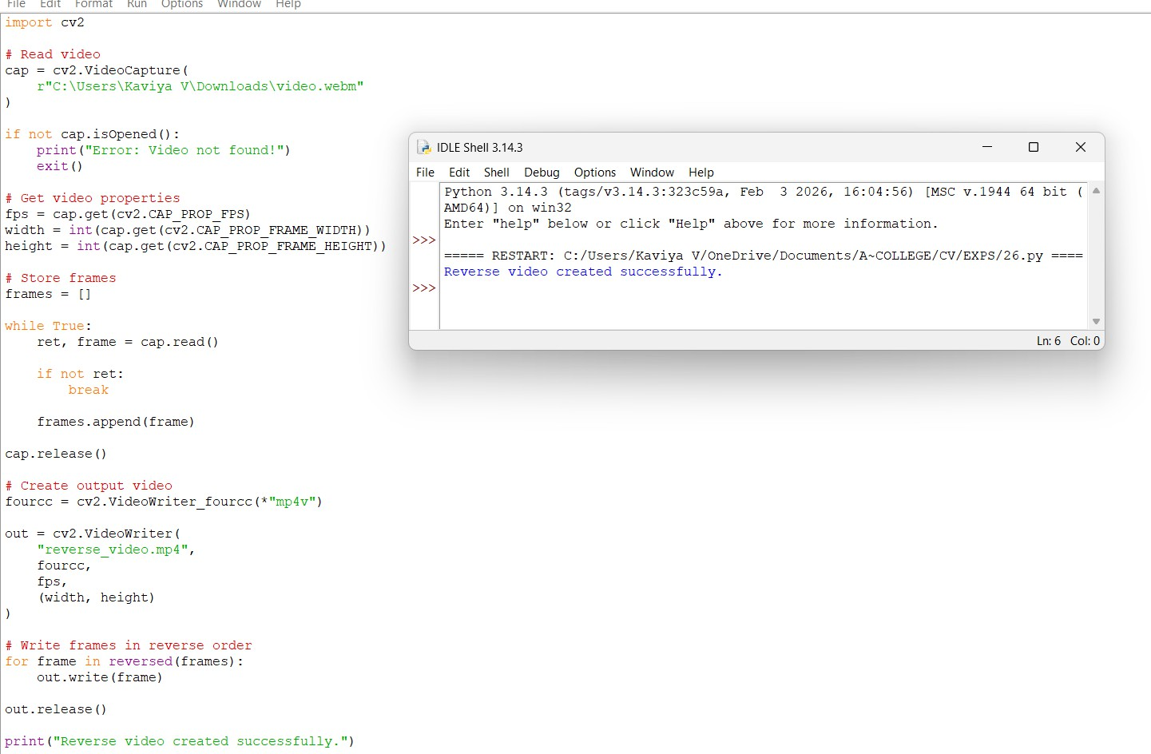
- Implement a function to reverse the frames of the video to create a video in reverse mode using Open CV.

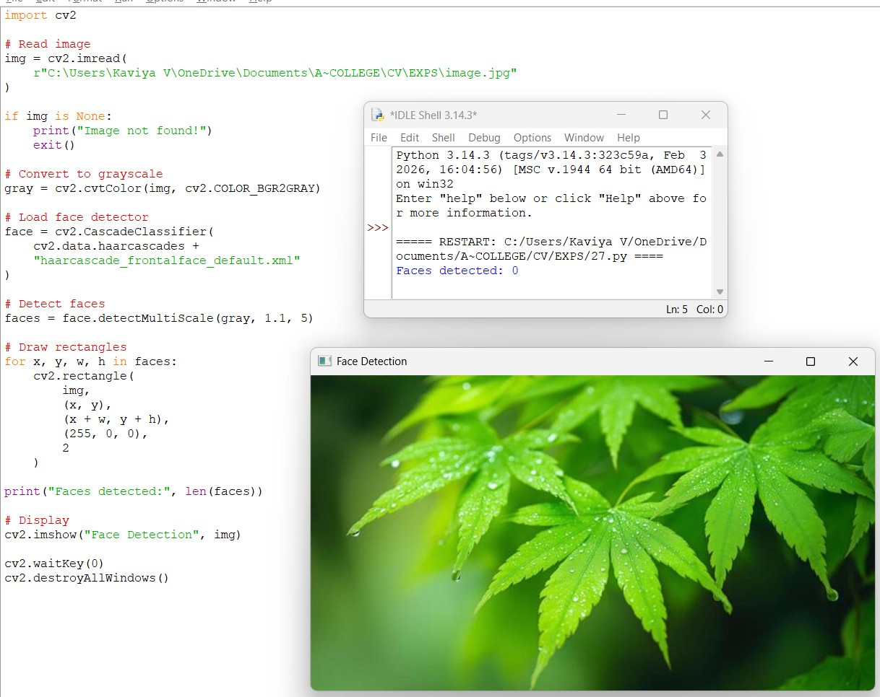
- Implement a face detection algorithm using Open CV to detect and locate human faces in the images.
- Implement a vehicle detection algorithm using Open CV to detect and locate vehicles in each frame of the video.
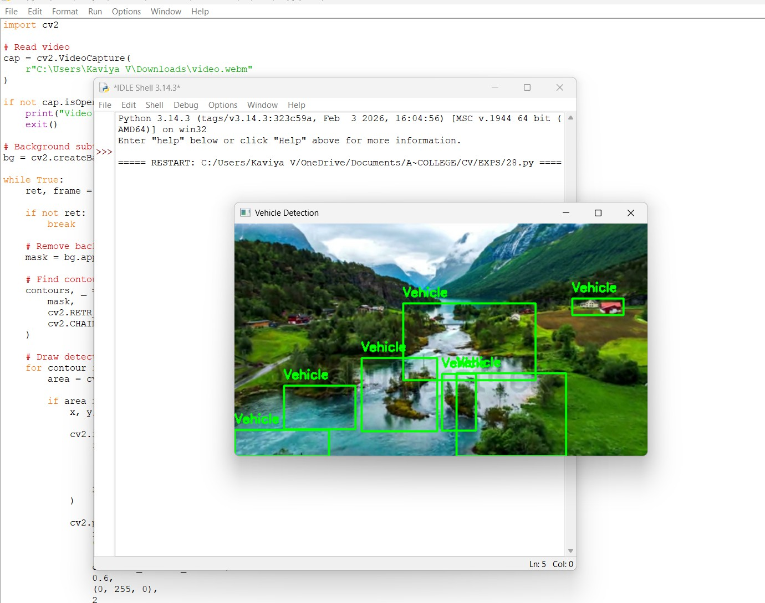

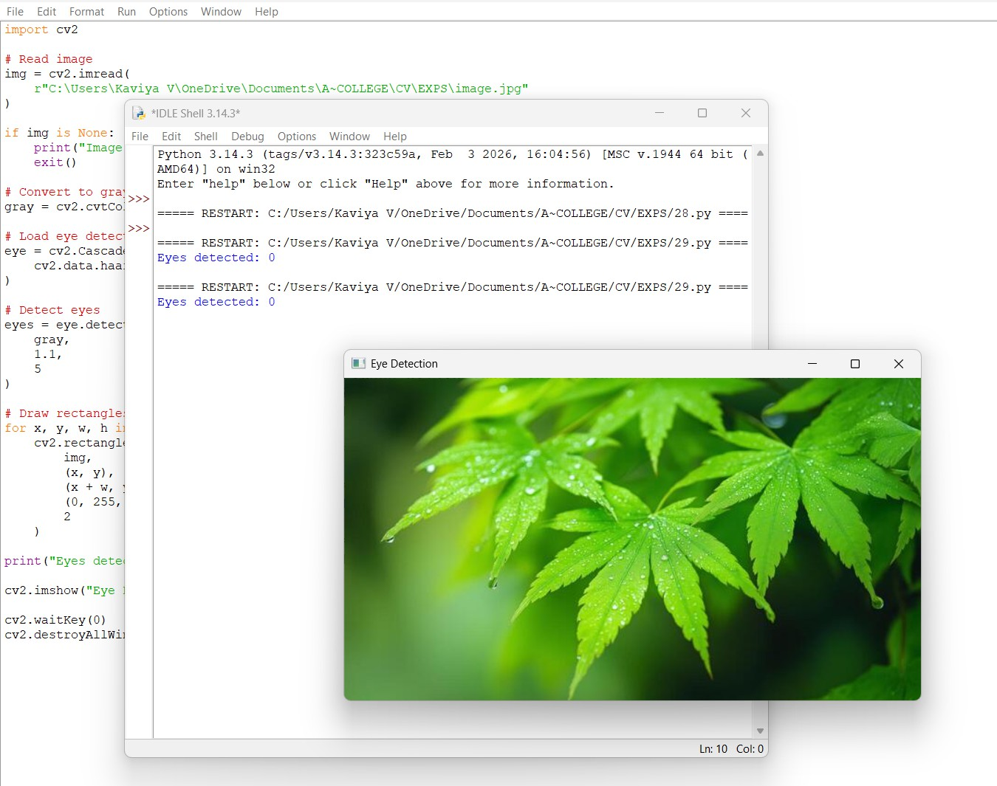
- Implement an Eye detection algorithm using Open CV to detect and locate human eyes in the images.
- Implement a Smile detection algorithm using Open CV to detect and locate human smile in the images.
